

**CU JOURNAL HUB**

SUBMITTED IN PARTIAL FULFILLMENT OF REQUIREMENTS FOR THE AWARD OF THE DEGREE OF **MASTER OF SCIENCE IN COMPUTER SCIENCE**

**OF**

**UNIVERSITY OF CALICUT**

SUBMITTED BY

**Ms. SANSI**

**Reg. No: CUAWCMF017**

UNDER THE GUIDANCE OF

### DR.LAJISH V.L



**DEPARTMENT OF COMPUTER SCIENCE UNIVERSITY OF CALICUT**

**2024**



This is to certify that the project work entitled “**CU JOURNAL HUB”** is a bonafide record of original work done by **Ms. SANSI** (CUAWCMF017) final year M.Sc. Computer Science in partial fulfillment of the requirements for the award of the degree in Master of Computer Science during the period of 2022-2024.

Project Guide:

**Dr.Lajish V.L**

Head of the Department

Certified of the candidate SANSI (CUAWCMF017) is examined by us in the project viva voice.

Examination held on: …………………….

Signature of Examiners

1 . ……………………..

2 . ……………………..

Calicut university Date

I here by declare that the project entitled “**CU JOURNAL HUB”** submitted to the **Department of Computer Science, University of Calicut** in partial fulfilment of the requirements for the award of degree in **MSc. COMPUTER SCIENCE** is a record of original dissertation work done by me, Under the guidance and supervision of **Dr. LAJISH V.L Associate professor, Department of Computer Science, University of Calicut,Thenhipalam** during my study period in **CALICUT UNIVERSITY CAMPUS, MALAPPURAM.**

Place: Thenhipalam Date:



SANSI

Reg.No: CUAWCMF008



Presentation, inspiration and motivation have always played a key role in the success of any venture.

I express my sincere thanks to my guide **Dr. LAJISH V L Associate Professor & Head of The Department, Department of Computer Science**, **University of Calicut**. Whose valuable guidance and kind supervision given to me through the course which shaped the present work as its show

I pay my deep sense of gratitude to **Ms. MANJULA KA Associate Professor, Department of Computer Science**, **University of Calicut to** encourage me to the highest peak to provide me the opportunity to prepare project.

I wish to express my sincere thanks to faculty **Dr. ALJINU KHADAR K V Assistant Professor, Ms. HRIDYA E Assistant Professor, Mr. ISHAQUE K Assistant Professor, Department of Computer Science**, **University of Calicut** for their valuable suggestion and guidance throughout our project that helped us to develop and complete the project successfully.

I’m immensely obliged to my friends for their elevating inspiring, encouraging guidance and kind of supervision in the completion of my project.



**ABSTRACT**

Journals play a crucial role in academic and scientific communication, serving as platforms for researchers to share their findings with the broader community. The submitting process involves authors preparing their research findings according to the journal's guidelines and submitting them for peer review which ensures the quality and validity of the research before publication. Upon acceptance, the article undergoes editing and formatting before being published in the journal.

Currently the process of journal submission and reading are done through offline mode. In this project, we are providing an online journal portal for users to simplifies the submission process for authors and editors and with a user-friendly flipbook format, it enables effortless reading and navigation of articles. Users can browse and download articles straight from your phone, laptop, or tablet.



**INDEX**

|  |  |  |  |
| --- | --- | --- | --- |
| **Chapter No** | **Contents** | | **Page No** |
| 1 | INTRODUCTION | | 1 |
| 2 | SYSTEM STUDY | | 3 |
| 2.1 | EXISTING SYSTEM | 5 |
| 2.2 | PROPOSED SYSTEM | 6 |
| 2.3 | MODULE DESCRIPTION | 7 |
| 3 | SOFTWARE AND HARDWARE SPECIFICATION | | 9 |
| 3.1 | HARDWARE SPECIFICATION | 10 |
| 3.2 | SOFTWARE SPECIFICATION | 10 |
| 3.3 | LANGUAGE DESCRIPTION | 11 |
| 4 | SYSTEM ANALYSIS | | 14 |
| 4.1 | FEASIBILITY STUDY | 16 |
| 4.1.1 | TECHNICAL FEASIBILITY | 17 |
| 4.1.2 | OPERATIONAL FEASIBILITY | 17 |
| 4.1.3 | ECONOMICAL FEASIBILITY | 18 |
| 4.1.4 | BEHAVIOURAL FEASIBILITY | 18 |
| 4.1.5 | SOFTWARE FEASIBILITY | 18 |
| 4.1.6 | HARDWARE FEASIBILITY | 18 |



|  |  |  |  |
| --- | --- | --- | --- |
| 5 | SYSTEM DESIGN | | 19 |
| 5.1 | DATA FLOW DIAGRAM | 21 |
| 5.3 | DATABASE DESIGN | 29 |
| 6 | SYSTEM TESTING | | 37 |
| 6.1 | UNIT TESTING | 39 |
| 6.2 | INTEGRATION TESTING | 39 |
| 6.3 | VALIDATION TESTING | 40 |
| 6.4 | INPUT TESTING | 40 |
| 6.5 | OUTPUT TESTING | 40 |
| 6.6 | USER ACCEPTANCE TESTING | 40 |
| 7 | FUTURE ENHANCEMENT | | 41 |
| 8 | CONCLUCION | | 43 |
| 9 | APPENDIX | | 45 |
| 9.1 | SCREEN SHOT | 46 |
| 9.2 | SAMPLE CODE |  |
| 10 | BIBILIOGRAPHY | | 52 |



# INTRODUCTION



## INTRODUCTION

In our current era of automated systems with it being either software or hardware, it’s not advisable to be using manual systems. Our online journal portal has many advantages over traditional offline methods. CU Journal Hub is a platform designed to make academic research articles easily accessible to everyone. Being online means anyone can interact with journals anytime, anywhere. It also saves a lot of paperwork and costs by making the submission and approval process smoother. The portal helps authors and editors collaborate in real-time, making the journal process faster. Plus, reading and organizing journals digitally makes them easier to find and use.

### Objectives

* Anyone can browse and read articles using a user-friendly flipbook format. They can also register to submit their own research for review.
* Registered users can submit their research articles to relevant journals for review by editors.
* Assigned editors can manage their journals by Uploading cover photos, reviewing and approving/rejecting submitted articles and addingdetails about the journal
* The admin has ultimate control over the platform and can add new editors, create new journals, view overall usage statistics like Visit counts for each journal and article , and Download counts for each article



# SYSTEM STUDY



## SYSTEM STUDY

System study is the first stage of system development life cycle. This gives a clear picture of what actually the physical system is. The system study is done in two phases. In the first phase, the preliminary survey of the system is done which helps in identifying the scope of the system. The second phase of the system study is more detailed and in-depth study in which the identification of user’s requirement and the limitations and problems of the present system are studied. After completing the system study, a system proposal is prepared by the user. Actually, A system study is essential for understanding the requirements, functionalities, and design considerations of a web portal.

With the guidance of our faculties, other departments, and the computer center, we gathered enough information and ideas to develop the journal project. Using the provided references, we developed a wide variety of ideas. We also looked into several journal portals of other universities and journals.



## EXISTING SYSTEM

Currently there is no proper online journal reading portals for university. Without a good website where university students can easily find and read academic journals, it's tough for them to get the information they need for their studies. They might have to spend a lot of time searching all over the internet for what they're looking for, and sometimes they might not even find it. This makes their research harder and can slow down their learning. Plus, without a central place to look, they might end up using old or incomplete sources. So, without a proper online journal portal, students face difficulty accessing the valuable information they need for their studies. So, having a proper online journal portal specifically for university would make students' lives a lot easier and help them learn better.



## PROPOSED SYSTEM

In the proposed system, It serves as a central hub, consolidating research journals from different departments into one user-friendly location, making scholarly articles easily accessible to everyone within and beyond the university. It also provide a user-friendly flipbook format for browsing and downloading articles and also encourage public users to register and participate by submitting their own research for review.

### Advantages:

* Effortless Access
* User friendly
* Simplified Submissions
* Efficient Management
* Digital Reading
* Search Made Easy



## MODULE DESCRIPTION

The project CU JOURNAL HUB is a brand new online platform which is designed to the public users for effortless access and user friendly format for submitting Articles and which are presented in a flipbook format, making them easy to read digitally and navigate. The portal helps authors and editors collaborate in real-time, making the journal process faster. The project mainly consists of four modules which are:

* Admin Module
* Editor Module
* Author Module
* User Module

### ADMIN MODULE

### In administrator module administrator has ultimate control over the platform and can add new editors and create new journals. And also view the created journals to edit and remove. View overall usage statistics like visit counts for each journal and article and also download counts for each article

### EDITOR MODULE

The editor module has several essential functionalities to enhance the assigning process. The assigned editors can manage their journals by uploading their coverphotos, Reviewing and approving/rejecting submitted articles and Adding details about the journal which includes ethics statements, Aims& scopes, author guidelines, editorialbord members, important notifications and contact informations.

### AUTHOR MODULE

In the author module the registered users can submit their research articles to relevant journals for review by assigned editors within relevant departmental journals. They can also check the status of their uploaded journal articles, whether they have been approved or rejected.

### PUBLIC MODULE

Anyone can explore a vast collection of research articles from different departments. Articles are presented in a user-friendly flipbook format for easy reading and navigation. Public users can register for an account and submit their articles to relevant journals managed by our faculty editors.



# SOFTWARE AND HARDWARE SPECIFICATION



### HARDWARE SPECIFICATION

Processor **:** Core i3 or above

Ram **:** 4GB

Hard Disk **:** 512 GB or above Keyboard **:** Standard

Mouse **:** Standard

### SOFTWARE SPECIFICATION

Platform **:** Windows 8 or above

Front End **:** HTML, CSS , JAVASCRIPT ,BOOTSTRAP

Back End **:** Django

Browser **:** Google Chrome, Mozilla Firefox, Internet Explorer

Database **:** MySQL



**LANGUAGE DESCRIPTION**

### HTML

**HTML** stands for Hyper Text Markup Language. It is used to design web pages using markup language. HTML is the combination of Hypertext and Markup language. Hypertext defines the link between the web pages. Markup language is used to define the text document within tag which defines the structure of web pages. This language is used to annotate (make notes for the computer) text so that a machine can understand it and manipulate text accordingly. Most of markup languages are human readable.

HTML is a markup language which is used by the browser to manipulate text, images and other

content to display it in required format. HTML was created by Tim Berners-Lee in 1991. The first ever version of HTML was HTML 1.0.HTML uses predefined tags and elements which tells the browser about content display property. If a tag is not closed then browser applies that effect till end of page.

### CSS (Cascading Style Sheet)

A CSS (cascading style sheet) file allows you to separate your web sites HTML content from its style. As always you use your HTML file to arrange the content, but all of the presentation (fonts, colors, background, borders, text formatting, link effects & so on...) are accomplished within a CSS. At this point you have some choices of how to use the CSS, either internally or externally. First, we will explore the internal method. This way you are simply placing the CSS code within the tags of each HTML file you want to style with the CSS. The format for this is shown in the example below. Inline styles are defined right in the HTML file along side the element you want to style. An external CSS file can be created with any text or HTML editor. A CSS file contains no (X)HTML, only CSS. You simply save it with the .css file extension.



### JAVASCRIPT

JavaScript is a versatile programming languagecommonly used for web development.It enables interactive elements on websites, such as dynamic content, animations, and user input validation. JavaScript can run on both the client side (in web browsers) and the server side (with platforms like Node.js). It’s known for its flexibility, as it supports multiple programming paradigms like object-oriented, functional, and imperative styles. JavaScript plays a key role in modern web development alongside HTML and CSS, forming the backbone of many interactive and dynamic web applications.

### BOOTSTRAP

### Bootstrap is a popular front-end framework for building responsive and mobile-first websites and web applications.It provides a collection of pre-designed templates, components, and utilities, including grids, buttons, forms, navigation bars, and more, to help developers create consistent and visually appealing interfaces with ease. Bootstrap uses HTML,CSS,and JavaScript, offering a simple and efficient way to design and customize responsive layouts that adapt to various screen sizes and devices.It streamlines the development process by providing a solid foundation and reusable components, making it a preferred choice for developers aiming to create modern and responsive web experiences

### DJANGO

Django is a Python-based web framework that allows you to quickly create efficient web applications. It is also called batteries included framework because Django provides built-in features for everything including Django Admin Interface, default database – SQLlite3, etc. When you’re building a website, you always need a similar set of components: a way to handle user authentication (signing up, signing in, signing out), a management panel for your website, forms, a way to upload files, etc. Django gives you ready-made components to use and that too for rapid development. Django’s primary goal is to ease the creation of complex database-driven websites. Some well known sites that use Django include PBS, Instagram, Disqus, Washington Times, Bitbucket and Mozilla.



### PYTHON

Python is a general-purpose, dynamic, high-level, and interpreted programming language. It supports Object Oriented programming approach to develop applications. It is simple and easy to learn and provides lots of high-level data structures.Python is an easy-to-learn yet powerful and versatile scripting language, which makes it attractive for Application Development. With its interpreted nature, Python's syntax and dynamic typing make it an ideal language for scripting and rapid application development. Python supports multiple programming patterns, including object- oriented, imperative, and functional or procedural programming styles. Python is not intended to work in a particular area, such as web programming. It is a multipurpose programming language because it can be used with web, enterprise, 3D CAD, etc.We don't need to use data types to declare variable because it is dynamically typed, so we can write a=10 to assign an integer value in an integer variable. Python makes development and debugging fast because no compilation step is included in Python development, and the edit-test-debug cycle is very fast.



# SYSTEM ANALYSIS



## SYSTEM ANALYSIS

System Analysis is concerned with analyzing, designing, implementing and evaluating information system in our organization. It is carried out to make the system more effective either by modification or by substantial redesign. In system analysis we identify the problem, study the alternative solution and select the most suitable solution, which meet the technical economic and social demands for analysis, various tools such as dataflow diagram, interviews on site observation, questionnaires etc., are used. System analysis process is also called a life cycle methodology since it relates to four significant phases in life cycle of all information system. They are

1. System Analysis / Study Phase.
2. System Design / Design phase.
3. System Development / Development Phase.
4. Testing and implementation / Operation Phase.

All activities associated with each life cycle phase must be performed managed and documented. So, system analysis is the performance, management and documentation of the activities related to the four life cycle phases of a computer-based system



## FEASIBILITY STUDY

The most difficult part of feasibility analysis is the identification of the Candidate system and the evaluation of their performance. Feasibility study is a test of a system proposal according to its workability, impact on the organization, ability to meet the user needs and effective use of resources.

A feasibility study is conducted to select the best system that meets performance requirements. The entails an identification description, an evaluation of candidate system, and the selection of the best system for the job. The new system has advantages such as we can easily doing transactions in the shop and this application is more user friendly for the employees. Six key considerations are involved in the feasibility analysis:

* 1. Technical Feasibility
  2. Operational Feasibility
  3. Economical Feasibility
  4. Behavioral Feasibility
  5. Software Feasibility
  6. Hardware Feasibility



### TECHNICAL FEASIBILITY

A study of function, performance and constraints may improve the ability to create an acceptable system. Technical Feasibility is frequently the most difficult area to achieve at the stage of product engineering process. Considering that are normally associated with the technical feasibility include,

* Development risk
* Resource availability
* Technology

Technical Feasibility study deals with the hardware as well as software requirements. The scope was whether the work for the project is done with the current requirements and existing software technology has to be examined in the feasibility study.

The outcome was found to be positive. In the proposed system, data can be easily stored and managed using database management system software. The reports and results for various queries can be generated easily. Therefore, the system is technically feasible.

### OPERATIONAL FEASIBILITY

Proposed projects are beneficial only if they can be turned into information system that will meet the organization’s operating requirements. Simply stated, this test of feasibility asks if the system will work when it is developed and installed. Are these major barriers to implementation?

The purpose of the operational feasibility study is to determine whether the new system will be used if it is developed and implemented from users that will undermine the possible application benefits. There was no difficulty in, implementing the system and the proposed system is so effective, user friendly and functionally reliable so that the users in the company will find that the new system reduce their hard steps. If the user of the system is fully aware of the internal working of the system then the users will not be facing any problem in running the system.



### ECONOMICAL FEASIBILITY

Proposed system was developed with the available resources. Since cost input for the software is almost nil the output of the software is always a profit. Hence software is economically feasible. In the existing system, manpower is more required. In the proposed system the effort to be involved is reduced drastically. So, the proposed system is said to be economic.

### BEHAVIORAL FEASIBILITY

People are inherently resistant to changes and computer is known as facilitating the changes. An estimate should be made of how strongly the users react to the development of the system. The proposed system consumes time. Thus the people are made to engage in some other important work.

### SOFTWARE FEASIBILITY

Even though software is developed in very high software environment, it will be supported by many other and environments with minimum changes.

### HARDWARE FEASIBILITY

The software can be developed with resource already existing. Here the consideration is that the existing hardware resources support the technologies that are to be used by the new system. No hardware was newly bought for the project and hence software is said to achieve hardware feasibility. The software can be developed with resource already existing. Here the consideration is that the existing hardware resources support the technologies that are to be used by the new system. No hardware was newly bought for the project and hence software is said to achieve hardware feasibility.



# SYSTEM DESIGN



## SYSTEM DESIGN

System Design involves translating system requirements and conceptual design into technical specification and general flow of processing. After the system requirements have been identified, information has been gathered to verify the problems and after evaluating the existing system a new system is proposed. System Design is the process of planning of new system or to replace or complement an existing system. It must be thoroughly understood about the old system determine how computers can be used to make its operations more effective.

System Design sits at technical the kernel of the system development. Once system requirements have been analyzed and specified system design is the first of the technical activities – design, code generation and test that required to build and verify the software. System Design is the most creative and challenging phases of the system life cycle. The term design describes the final system and the process by which it is to be developed.

System Design is the high-level strategy for solving the problem and building a solution. System Design includes decisions about the organization of the system into subsystems, the allocation of subsystems to hardware and software components and major conceptual and policy decision that forms the framework for detailed design.



### DATA FLOW DIAGRAM

A Data Flow Diagram is used to define the flow of data and the resources such as information. Data Flow Diagrams are a way of expressing system requirements in graphical manner .it has the purpose of clarifying system requirements and identifying the major transformation that will become program in the system design. So it is the starting point of design phase that functionally decomposes the requirement specification down in to the lowest level of details. The bubbles represent data transformation and the lines represent information flow in the system. Data Flow Diagrams are useful in understanding a system and can be effectively used for partitioning. The system may be an organization, a manual procedure, software system, a mechanical system or any combination of these.

### Rules For Constructing a Data Flow Diagram

Process should be named and numbered for easy reference. Each name should be Representative of process. The direction of flow is from top to bottom and from left to right. That is information flow should be from source to destination. Numbering is given when a process is exploded into lower-level details. The name of the dad stores, source and destination are written in capital letters. Process and Data Flow names have the first letter of each word capitalized. The Data Flow Diagram is particularly designed to aid communication. If it contains dozens of process and data stores it gets too unwieldy. The rule of the thumb is to explode the DFD into a functional level beyond that, it is best to take each function separately and expand it to show the explosion in a single process. If a user wants to know what happens within a given process, then the detailed explosion of that process may be shown.

The goal of DFD is to have a commonly understood model of a system. The diagram is the basis of structured system analysis. DFD are supported by other techniques of structured system analysis. DFD are supported by other techniques of structured system analysis such as structured diagrams, and data dictionaries.



### DFD SYMBOLS

Data Flow Diagrams are composed of the four basis symbols shown below



A data is a root, which enables packet of data to travel from one point to another. Data may flow from a source to a processor and from data source or process. An arrow line depicts the flow, with arrowhead pointing in the direction of flow.

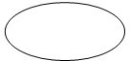

A process represents transformation where incoming data changed into outgoing data flows.



An open-ended box represents a data store, data at rest or a temporary repository of data.



A square defines a source or destination of system data.



### LEVEL 0

Data Flow Diagrams are composed of the four basis symbols shown below

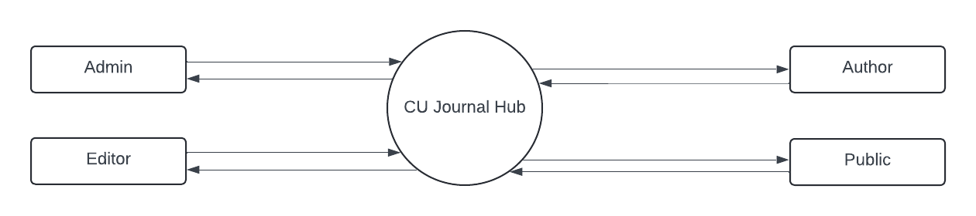

### LEVEL 1: ADMIN

**LEVEL 1: EDITOR**



**LEVEL 1: AUTHOR**

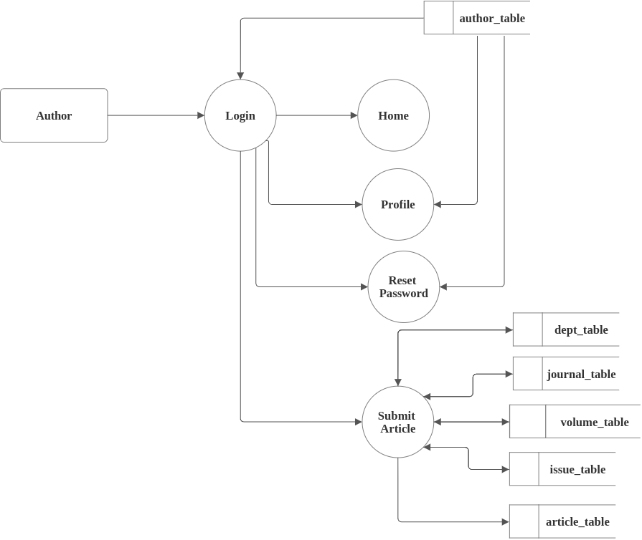



**LEVEL 1: PUBLIC**

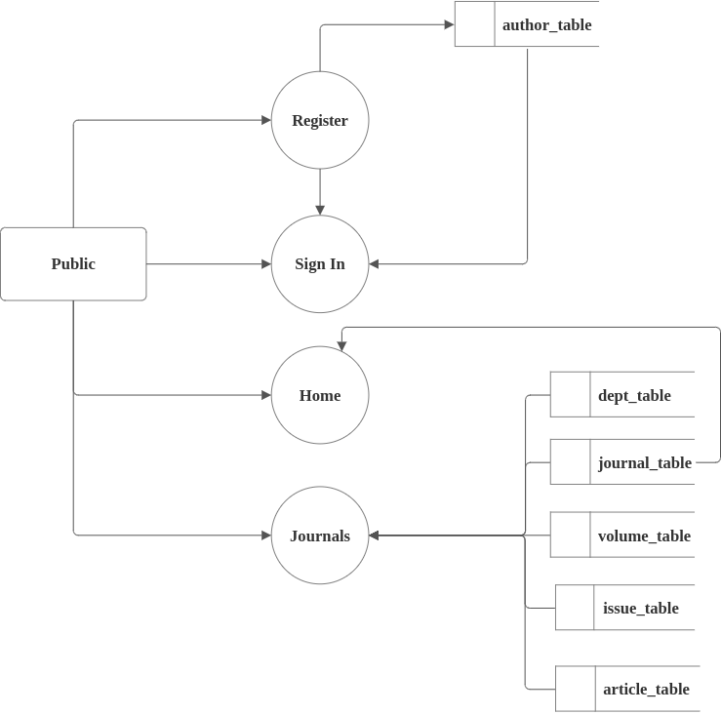

**LEVEL 2: A****DMIN**



**LEVEL 2: EDITOR**

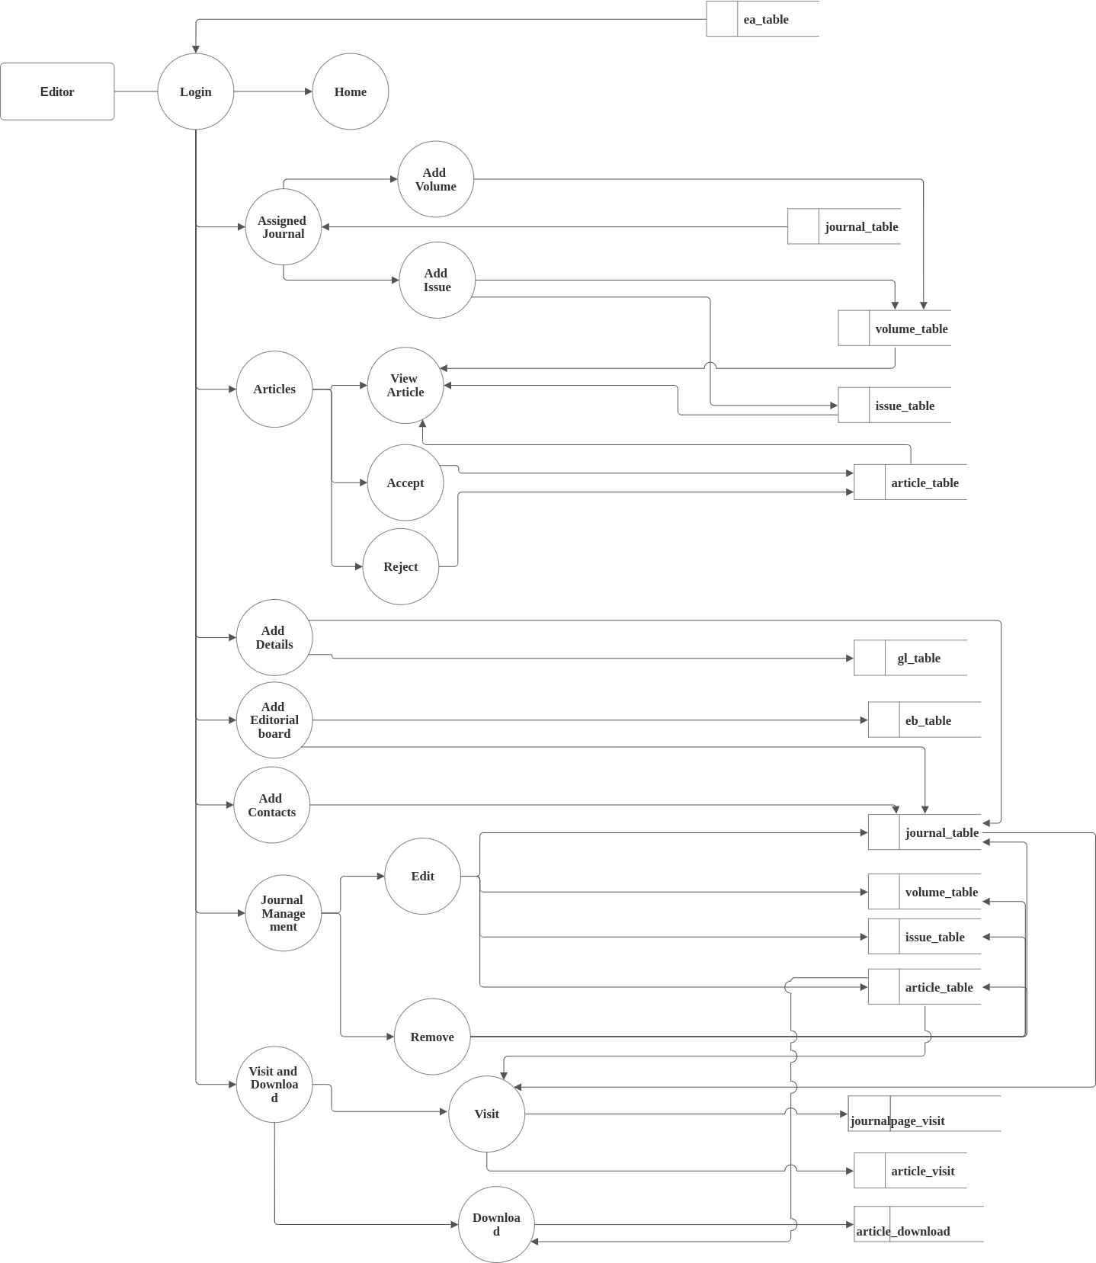

## LEVEL 2: PUBLIC

## 

## DATABASE DESIGN

The data base design is a logical development in the methods used by the computer to access and manipulate data stored in the various parts of the computer system. Database is defined as an integrated collection of data. The overall objective in the development of database technology has been to treat data as organization recourses and as an integrated while. The main objectives of database are data integration, data integrity and data independence*.*

### MYSQL

MySQL is an open-source relational database management system (RDBMS) that is widely used for managing and storing data. . It's known for its reliability, scalability, and ease of use, making it a popular choice for various applications, from small-scale websites to large-scale enterprise systems. MySQL uses Structured Query Language (SQL) for querying and managing data, allowing users to perform tasks like storing, retrieving, updating, and deleting data in databases. It supports multiple storage engines, allowing users to optimize their databases for specific use cases. MySQL is highly customizable, offering features such as replication, clustering, and high availability for ensuring data integrity and reliability. It's supported on various operating systems and platforms, making it versatile and widely adopted across different industries and applications.

### Normalization

Normalization is the process of organizing data in a database. This includes creating tables and establishing relationships between those tables according to rules designed both to protect the data and to make the database more flexible by eliminating redundancy and inconsistent dependency. Redundant data wastes disk space and creates maintenance problems. If data that exists in more than one place must be changed, the data must be changed in exactly the same way in all locations. Database normalization is a database schema design technique, by which an existing schema is modified to minimize redundancy and dependency of data.



### st Normal Form (1NF)

In this Normal Form, we tackle the problem of atomicity. Here atomicity means values in the table should not be further divided. In simple terms, a single cell cannot hold multiple values. If a table contains a composite or multi-valued attribute, it violates the First Normal Form.

### nd Normal Form (2NF)

The first condition in the 2nd NF is that the table has to be in 1st NF. The table also should not contain partial dependency. Here partial dependency means the proper subset of candidate key determines a non-prime attribute.

### rd Normal Form (3NF)

The same rule applies as before i.e., the table has to be in 2NF before proceeding to 3NF. The other condition is there should be no transitive dependency for non-prime attributes. That means non-prime attributes (which doesn’t form a candidate key) should not be dependent on other non-prime attributes in a given table. So a transitive dependency is a functional dependency in which X → Z (X determines Z) indirectly, by virtue of X → Y and Y → Z (where it is not the case that Y → X)



## TABLE DESIGN

1. **Table Name: Dept_Table**

|  |  |  |  |
| --- | --- | --- | --- |
| **Sl.No** | **Field** | **Data type** | **Constraints** |
| 1 | Dept_id | Integer Field | Primary Key |
| 2 | Dept_name | CharField(50) |  |
| 3 | Created_at | DateTimeField |  |
| 4 | Updated_at | DateTimeField |  |

1. **Table Name: EA_Table**

|  |  |  |  |
| --- | --- | --- | --- |
| **Sl.No** | **Field** | **Data type** | **Constraints** |
| 1 | Ea_id | BigAutoField | Primary Key |
| 2 | Dept_id | BigAutoField | ForeignKey |
| 3 | Employee_id | Char Field(50) |  |
| 4 | Ea_name | Char Field(50) |  |
| 5 | Ea_email | Char Field(90) |  |
| 6 | Ea_mobile | Char Field(20) |  |
| 7 | Ea_address | Char Field(200) |  |
| 8 | password | Char Field(90) |  |
| 9 | Ea_type | Char Field(70) |  |
| 10 | Token | Char Field(90) |  |
| 11 | Status | Char Field(50) |  |

1. **Table Name: Role_Table**

|  |  |  |  |
| --- | --- | --- | --- |
| **Sl.No** | **Field** | **Data type** | **Constraints** |
| 1 | Role_id | BigAutoField | Primary Key |
| 2 | Role_name | Char Field(30) |  |



**4. Table Name: Designation_Table**

|  |  |  |  |
| --- | --- | --- | --- |
| **Sl.No** | **Field** | **Data type** | **Constraints** |
| 1 | Designation_id | BigAutoField | Primary Key |
| 2 | Role_id | BigAutoField | ForeignKey |
| 3 | Designation | Char Field(30) |  |

**5. Table Name: Seat_Table**

|  |  |  |  |
| --- | --- | --- | --- |
| **Sl.No** | **Field** | **Data type** | **Constraints** |
| 1 | Seat_id | BigAutoField | Primary Key |
| 2 | Role_id | BigAutoField | ForeignKey |
| 3 | Seat_name | Char Field(30) |  |

**6. Table Name: User_Table**

|  |  |  |  |
| --- | --- | --- | --- |
| **Sl.No** | **Field** | **Data type** | **Constraints** |
| 1 | Usertable_id | BigAutoField | Primary Key |
| 2 | Seat_id | BigAutoField | ForeignKey |
| 3 | Ea_id | BigAutoField | ForeignKey |

**7. Table Name: User_Table**



|  |  |  |  |
| --- | --- | --- | --- |
| **Sl.No** | **Field** | **Data type** | **Constraints** |
| 1 | Author_id | BigAutoField | Primary Key |
| 2 | Author_type | CharField(50) |  |
| 3 | Author_name | CharField(50) |  |
| 4 | Author_email | CharField(90) |  |
| 5 | Author_mobile | CharField(20) |  |
| 6 | Author_dob | DateField(20) |  |
| 7 | Author_address | CharField(250) |  |
| 8 | Author_institute | CharField(100) |  |
| 9 | Author_designation | CharField(50) |  |
| 10 | Author_password | CharField(90) |  |
| 11 | Created_at | DateTimeField |  |
| 12 | Updated_at | DateTimeField |  |
| 13 | Status | CharField(25) |  |
| 14 | Verify | BoolField(90) |  |
| 15 | Token | CharField(30) |  |

**8. Table Name: Journal_Table**

|  |  |  |  |
| --- | --- | --- | --- |
| **Sl.No** | **Field** | **Data type** | **Constraints** |
| 1 | Journal_id | BigAutoField | Primary Key |
| 2 | Dept_id | BigAutoField | ForeignKey |
| 3 | Editor_id | BigAutoField | ForeignKey |
| 4 | Journal_name | CharField(50) |  |
| 5 | Journal_aim | TextField |  |
| 6 | Journal_ethics | TextField |  |
| 7 | Logo | CharField(100) |  |
| 8 | Created_at | DateTimeField |  |
| 9 | Updated_at | DateTimeField |  |
| 10 | Created_by | CharField(50) |  |
| 11 | Status | CharField(25) |  |
| 12 | Email | CharField(90) |  |
| 13 | Phone | CharField(20) |  |



**9. Table Name: Volume_Table**

|  |  |  |  |
| --- | --- | --- | --- |
| **Sl.No** | **Field** | **Data type** | **Constraints** |
| 1 | Volume_id | BigAutoField | Primary Key |
| 2 | Journal_id | CharField(50) | ForeignKey |
| 3 | Volume | CharField(50) |  |
| 4 | Cover_image | ImageField |  |
| 5 | Created_at | DateTimeField |  |
| 6 | Updated_at | DateTimeField |  |
| 7 | Created_by | CharField(50) |  |
| 8 | Status | CharField(25) |  |

**10. Table Name: Issue_Table**

|  |  |  |  |
| --- | --- | --- | --- |
| **Sl.No** | **Field** | **Data type** | **Constraints** |
| 1 | Issue_id | BigAutoField | Primary Key |
| 2 | Volume_id | BigAutoField | ForeignKey |
| 3 | Issue_no | Char Field(30) |  |
| 4 | Created_at | DateTimeField |  |
| 5 | Updated_at | DateTimeField |  |
| 6 | Created_by | CharField(50) |  |
| 7 | Status | CharField(25) |  |

**11. Table Name: Article_Table**

|  |  |  |  |
| --- | --- | --- | --- |
| **Sl.No** | **Field** | **Data type** | **Constraints** |
| 1 | Article_id | BigAutoField | Primary Key |
| 2 | Author_id | BigAutoField | ForeignKey |
| 3 | Issue_id | BigAutoField | ForeignKey |
| 4 | Author1 | CharField(90) |  |
| 5 | Author2 | CharField(90) |  |
| 6 | Author3 | CharField(90) |  |
| 7 | Article_title | CharField(90) |  |
| 8 | Created_at | DateTimeField |  |
| 9 | Updated_at | DateTimeField |  |
| 10 | Created_by | CharField(50) |  |
| 11 | Status | CharField(25) |  |
| 12 | Article_file | FileField |  |

**12. Table Name: Eb_Table**

|  |  |  |  |
| --- | --- | --- | --- |
| **Sl.No** | **Field** | **Data type** | **Constraints** |
| 1 | Board_id | BigAutoField | Primary Key |
| 2 | Journal_id | BigAutoField | ForeignKey |
| 3 | Editor_name | CharField(25) |  |
| 4 | Editor_address | CharField(25) |  |
| 5 | Editor_email | CharField(25) |  |
| 6 | Article_mobile | CharField(25) |  |
| 7 | Created_at | DateTimeField |  |
| 8 | Updated_at | DateTimeField |  |
| 9 | Created_by | CharField(50) |  |
| 10 | Status | CharField(25) |  |
| 11 | Photo | ImageField |  |



**13. Table Name: Gl_Table**

|  |  |  |  |
| --- | --- | --- | --- |
| **Sl.No** | **Field** | **Data type** | **Constraints** |
| 1 | Gl_id | BigAutoField | Primary Key |
| 2 | Journal_id | BigAutoField | ForeignKey |
| 3 | Heading | Char Field(90) |  |
| 4 | Content | TextFied |  |
| 5 | Created_at | DateTimeField |  |
| 6 | Updated_at | DateTimeField |  |
| 7 | Created_by | CharField(50) |  |
| 8 | Status | CharField(25) |  |

**14. Table Name: Notification_Table**

|  |  |  |  |
| --- | --- | --- | --- |
| **Sl.No** | **Field** | **Data type** | **Constraints** |
| 1 | Notification_id | BigAutoField | Primary Key |
| 2 | Journal_id | BigAutoField | ForeignKey |
| 3 | Notification | Char Field(100) |  |
| 4 | Link | Char Field(100) |  |
| 5 | Created_at | DateTimeField |  |
| 6 | Updated_at | DateTimeField |  |
| 7 | Created_by | CharField(50) |  |
| 8 | Status | CharField(25) |  |

**15. Table Name: Article_Visit**

|  |  |  |  |
| --- | --- | --- | --- |
| **Sl.No** | **Field** | **Data type** | **Constraints** |
| 1 | Art_visit_id | BigAutoField | Primary Key |
| 2 | Article_id | BigAutoField | ForeignKey |
| 3 | Created_at | DateTimeField |  |
| 4 | Updated_at | DateTimeField |  |
| 5 | Created_by | CharField(50) |  |
| 6 | Status | CharField(25) |  |
| 7 | Count | IntegerField |  |



**16. Table Name: Journalpage_Visit**

|  |  |  |  |
| --- | --- | --- | --- |
| **Sl.No** | **Field** | **Data type** | **Constraints** |
| 1 | Journal_visit_id | BigAutoField | Primary Key |
| 2 | Journal _id | BigAutoField | ForeignKey |
| 3 | Count | IntegerField |  |
| 4 | Created_at | DateTimeField |  |
| 5 | Updated_at | DateTimeField |  |
| 6 | Created_by | CharField(50) |  |
| 7 | Status | CharField(25) |  |

**17. Table Name: Article_Download**

|  |  |  |  |
| --- | --- | --- | --- |
| **Sl.No** | **Field** | **Data type** | **Constraints** |
| 1 | Dld_id | BigAutoField | Primary Key |
| 2 | Article _id | BigAutoField | ForeignKey |
| 3 | Count | IntegerField |  |
| 4 | Created_at | DateTimeField |  |
| 5 | Updated_at | DateTimeField |  |
| 6 | Created_by | CharField(50) |  |
| 7 | Status | CharField(25) |  |

**18. Table Name: Message_Table**

|  |  |  |  |
| --- | --- | --- | --- |
| **Sl.No** | **Field** | **Data type** | **Constraints** |
| 1 | Msg_id | BigAutoField | Primary Key |
| 2 | Journal _id | BigAutoField | ForeignKey |
| 3 | Ea_id | BigAutoField | ForeignKey |
| 4 | Msg_name | CharField(50) |  |
| 5 | Msg_email | CharField(90) |  |
| 6 | Subject | CharField(200) |  |
| 7 | Message | CharField(50) |  |



# SYSTEM TESTING



## SYSTEM TESTING

Testing is the major quality measure employed during software development. After the coding phase, computer programs are available that can be executed for testing purposes. Testing not only has to uncover errors introduced during coding but also locates errors committed during the previous phases. Thus, the aim of testing is to uncover requirements, design or coding in the program. System testing is an expensive but critical process that can take as much as fifty percent of the budget for program development. Consequential, different levels of testing are employed. In fact a successful test is one that finds an error. The system performance criteria deals with turnaround time backup, file protection and human factor. A test for the user acceptance should be carried out. The package developed was taken through different levels of testing and required modifications were made. Testing is a vital to the success of the system. System testing makes a logical assumption that if all parts of the system are correct, the goal will be successfully achieved. The following points show how testing is essential.

* Existence of program defects of inadequacies is inferred
* Verifies whether the software behave as intended by its designer.
* Checks conformance with requirements specification/user needs.
* Assesses the operational reliability of the system.
* Test the performance of the system.
* Reflects the frequencies of actual user inputs.
* Find the fault which caused the output anomaly.
* Detect flaws and deficiencies in the requirements.
* Exercise the program using data like real data processed by the program.
* Test the system capabilities.



## TYPES OF TESTING

System testing is the state of implementation, which is aimed at ensuring that the system works accurately and efficiently before live operation commences. Testing is vital to the success of system. System testing makes a logical assumption that if all parts of the system are correct, the goal will be successfully achieved. The candidate system is subject to variety of tests.

* Unit Testing
* Integration Testing
* Validation Testing
* Input Testing
* Output Testing
* User Acceptance Testing

### Unit Testing

Unit testing focuses on the verification effort on the smallest unit of software design the software component module. Using the component level design as a guide, important control paths are tested to uncover the error within in the boundary of the module. The relative complexity of tests and uncovered error is limited by the constrained scope established for unit testing. Each module was tested individually and the errors are corrected.

### Integration Testing

Integration testing is a systematic technique for constructing the program structure while at the same time conducting test to uncover errors associated with interfacing. The objective is

to take unit test components and build a program structure that has been dictated by design. Each module after unit testing were integrated and tested and errors were fixed.



### Validation Testing

Here the inputs are given by the user are validated. This is the password validation, format of date are correct, textbox validation. Changes that need to be done after result of this testing. While verification is quality control process, quality assurance process carried out before the software is ready for release is known as validation testing. Its goal is to validate and be confident about the software product or system, that fulfills the requirements given by the customer. The two major areas when it should take place are in the early stages of software development and towards the end, when the product is ready for release. In other words, it is acceptance testing which is a part of validation testing.

### Input Testing

Here system is tested with all verifiable combination of inputs. User may type data in situations like entering password, numerical details etc. The system is tested with all the cases and it responded error messages.

### Output Testing

After performing the validation testing, the next step is output testing of the proposed system, since no system could be useful if it does not produce the required output in the specific format. The output generator or displayed by the system under consideration is tested by asking the user about the format required by them. The output format on the screen is found to be correct as the format was designed in the system design phase according to the user needs. As far as hardcopies are considered it goes in term with the user requirement. Hence output testing does not result any correction in the system.

### User Acceptance Testing

User acceptance testing is done in presence of user. User acceptance of a system is the key factor for the success of any system. The system under consideration is tested for user acceptance by constantly in touch with the prospective system users at time of developing and making changer wherever is done in regard to the following points:

* Input screen design
* Output screen design
* Menu driven system



# FUTURE ENHANCEMENT



## FUTURE ENHANCEMENT

* + Enhancing a journal portal with advanced features can significantly improve the journal submission for authors
  + Implementing AI algorithms to suggest relevant articles, journals, or topics based on users’ reading habits and preferences.
  + Introducing features that enable users to share articles, leave comments, and engage in discussions with others, fostering a sense of community and social interaction.
  + Implementing features that cater to users with disabilities, such as text-to-speech functionality, high contrast mode, or screen reader compatibility.
  + Providing users with analytics and insights on their reading habits, helping them track their progress, and identify areas for improvement.
  + Incorporating gamification elements, such as badges, leaderboards, or rewards, to encourage users to engage with the journal, read more, and explore new topics.



# CONCLUSION



## CONCLUSION



# APPENDIX



## SCREEN SHOTS

## 

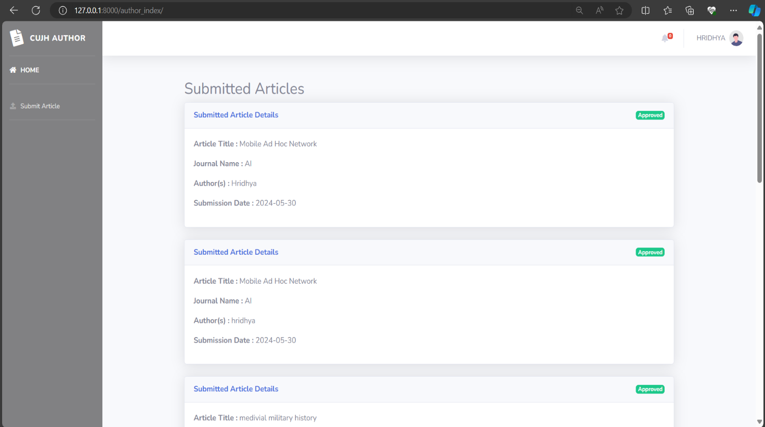



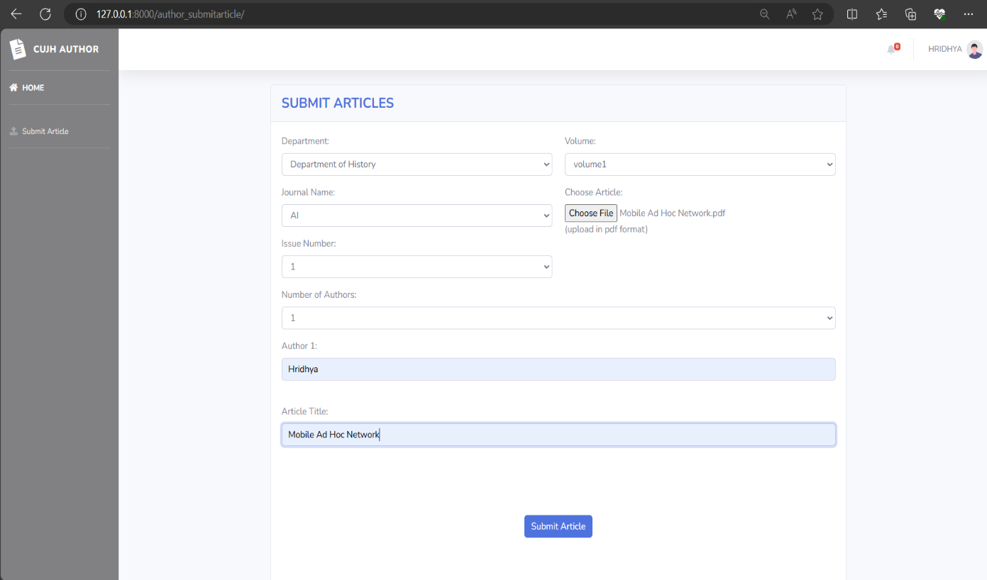

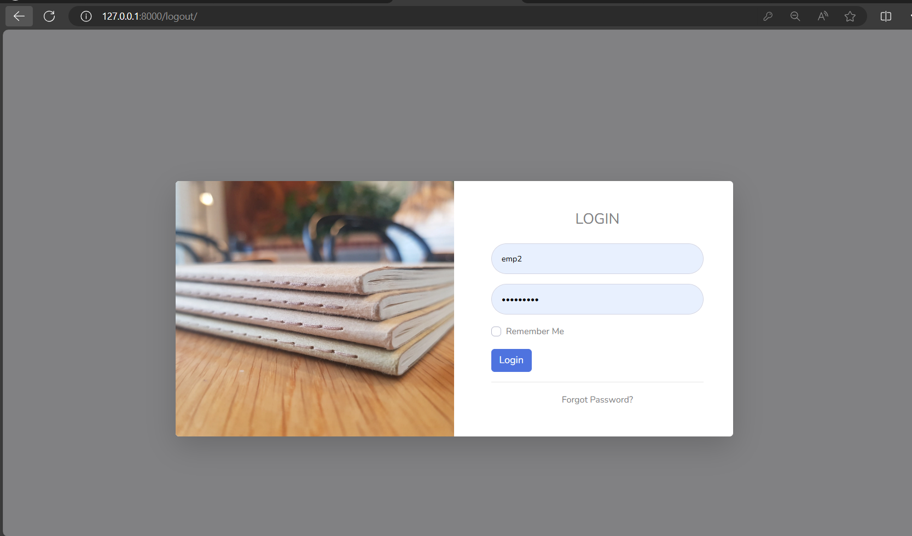



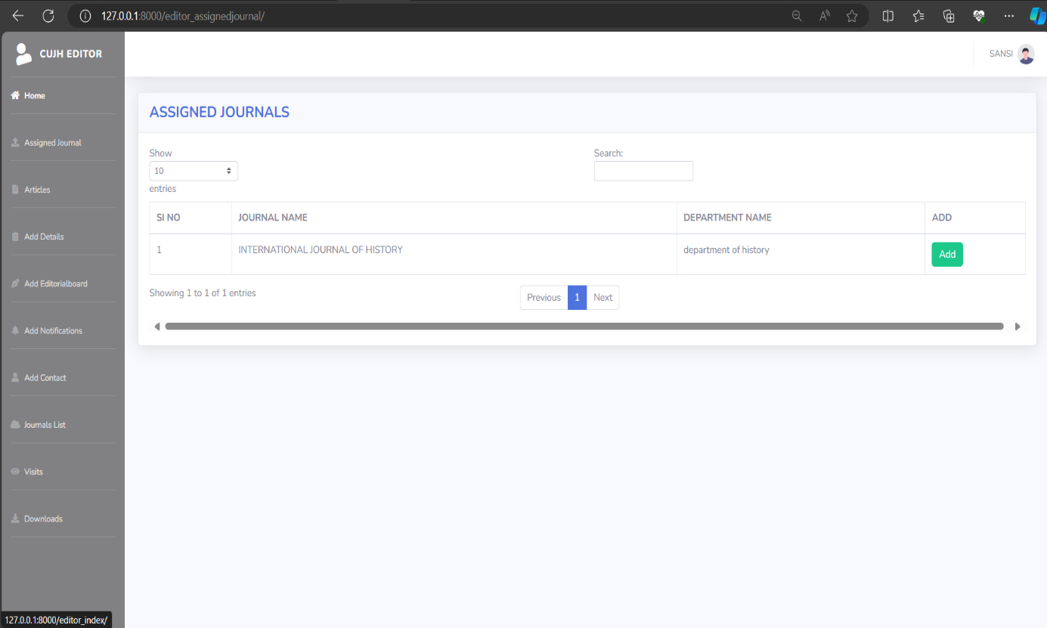

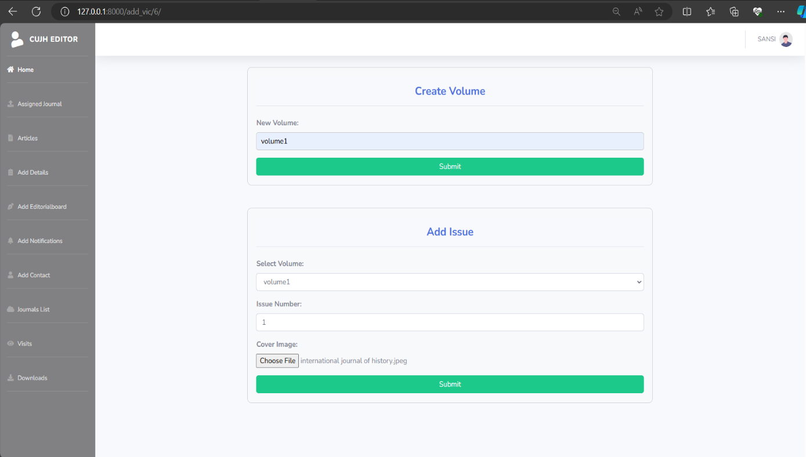



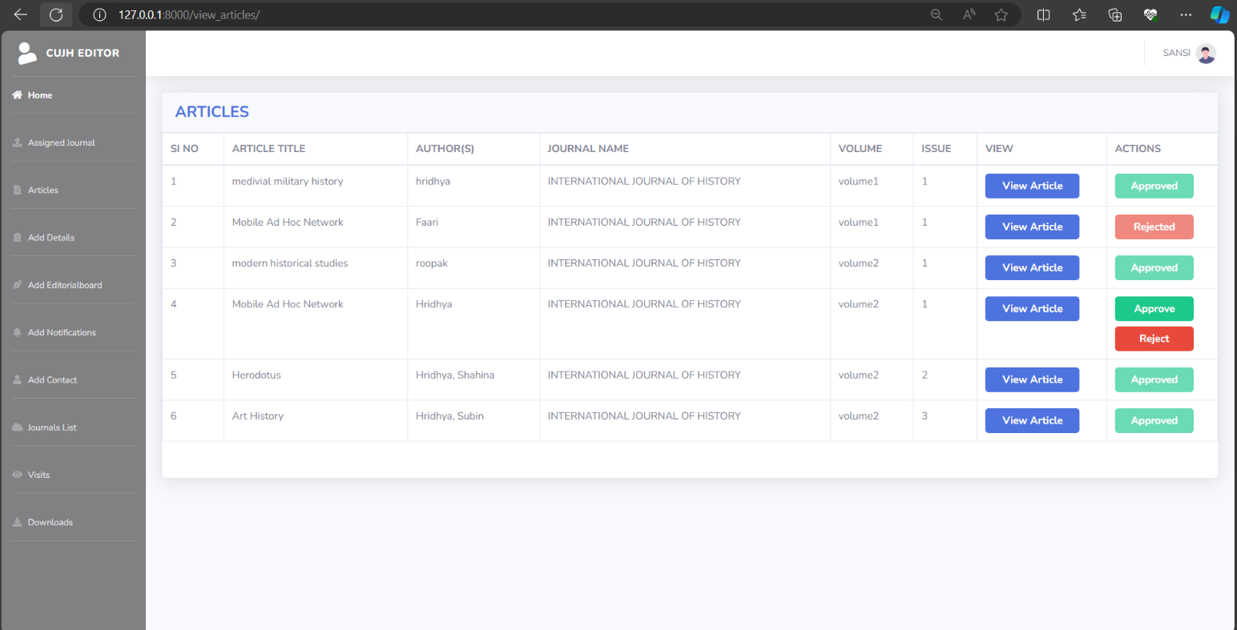

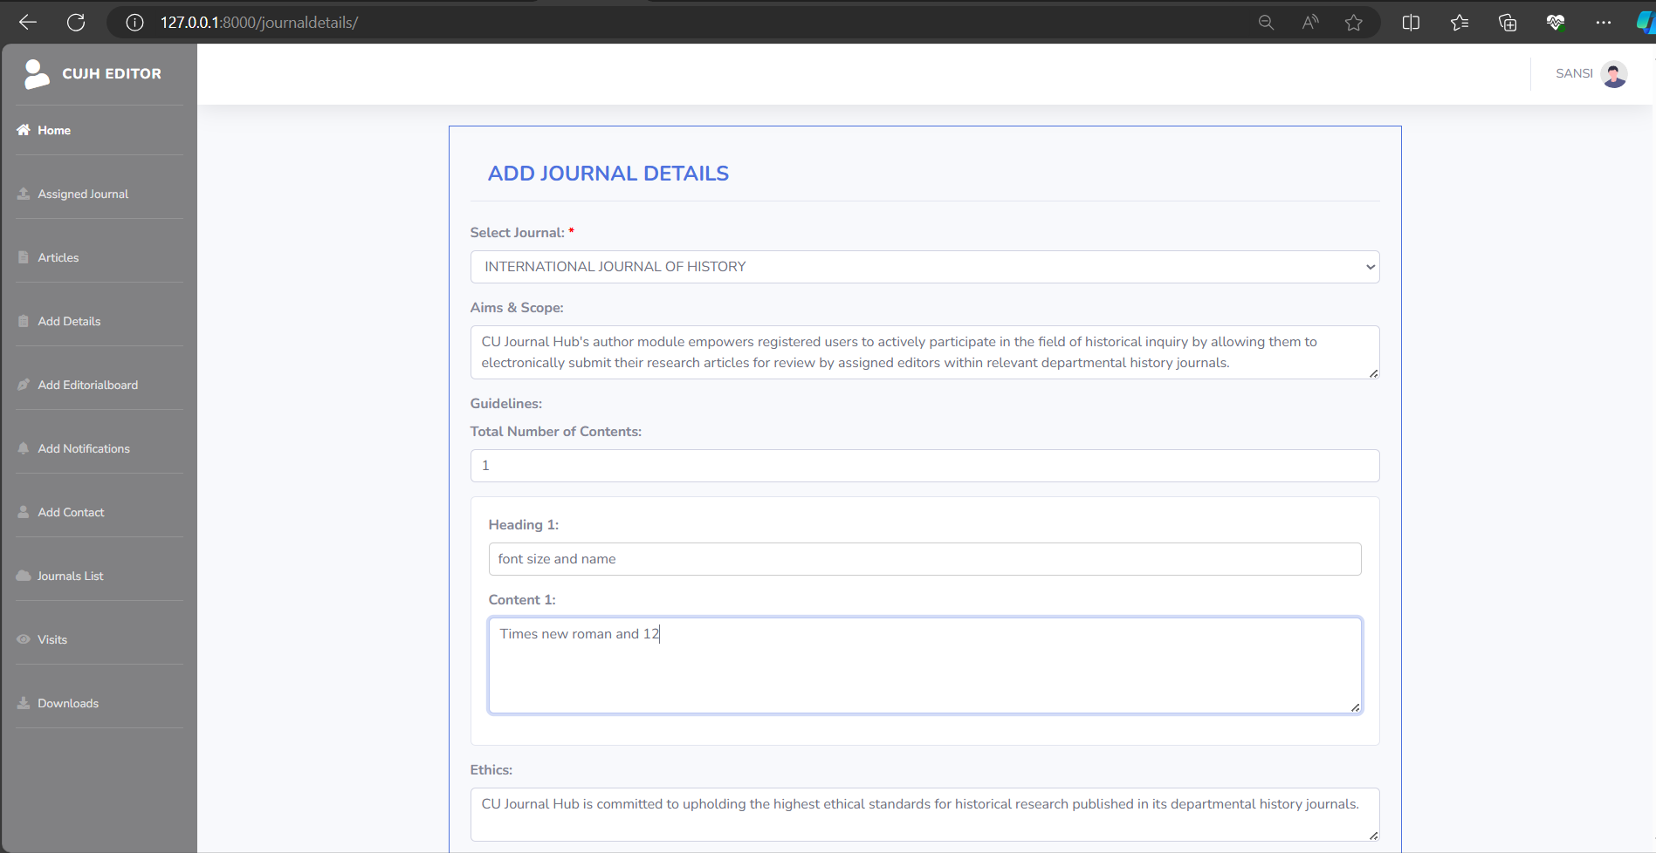



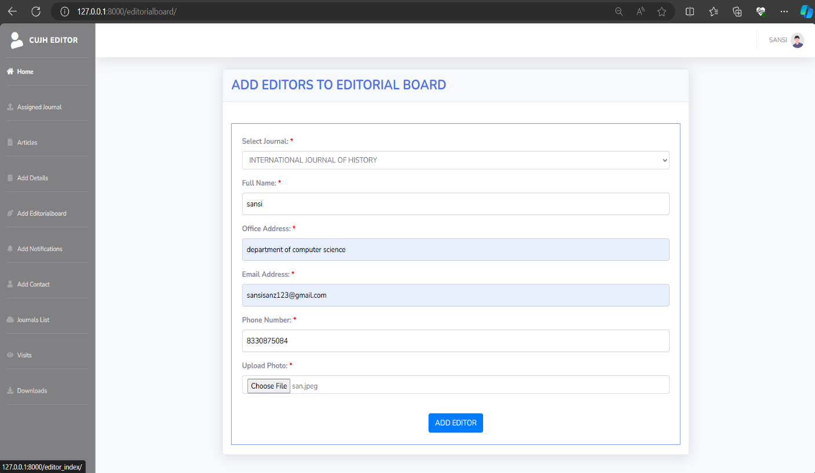

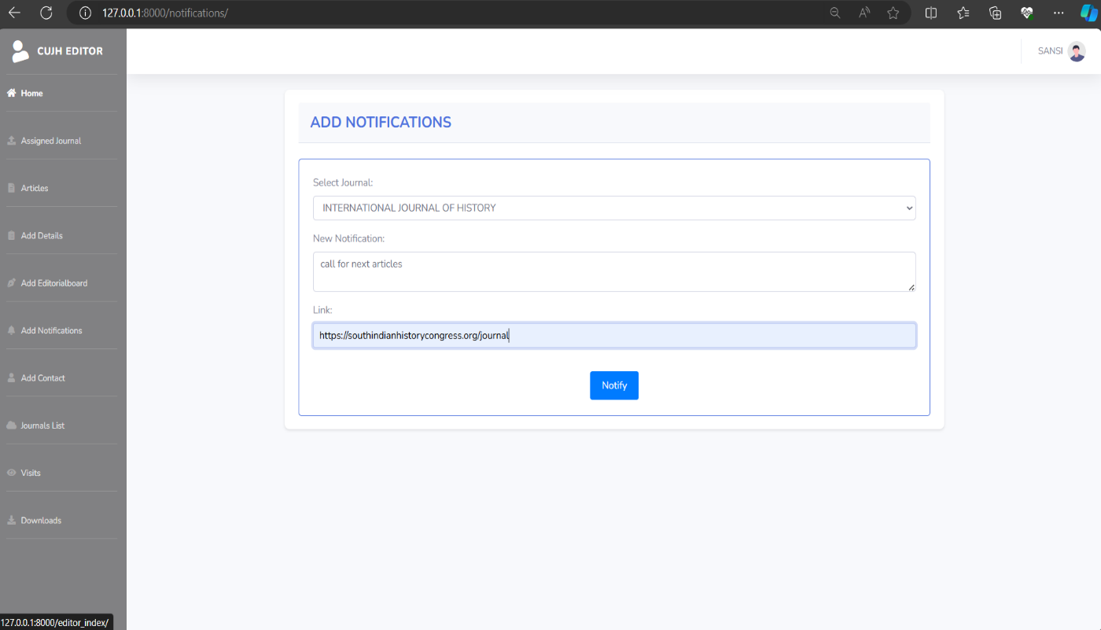



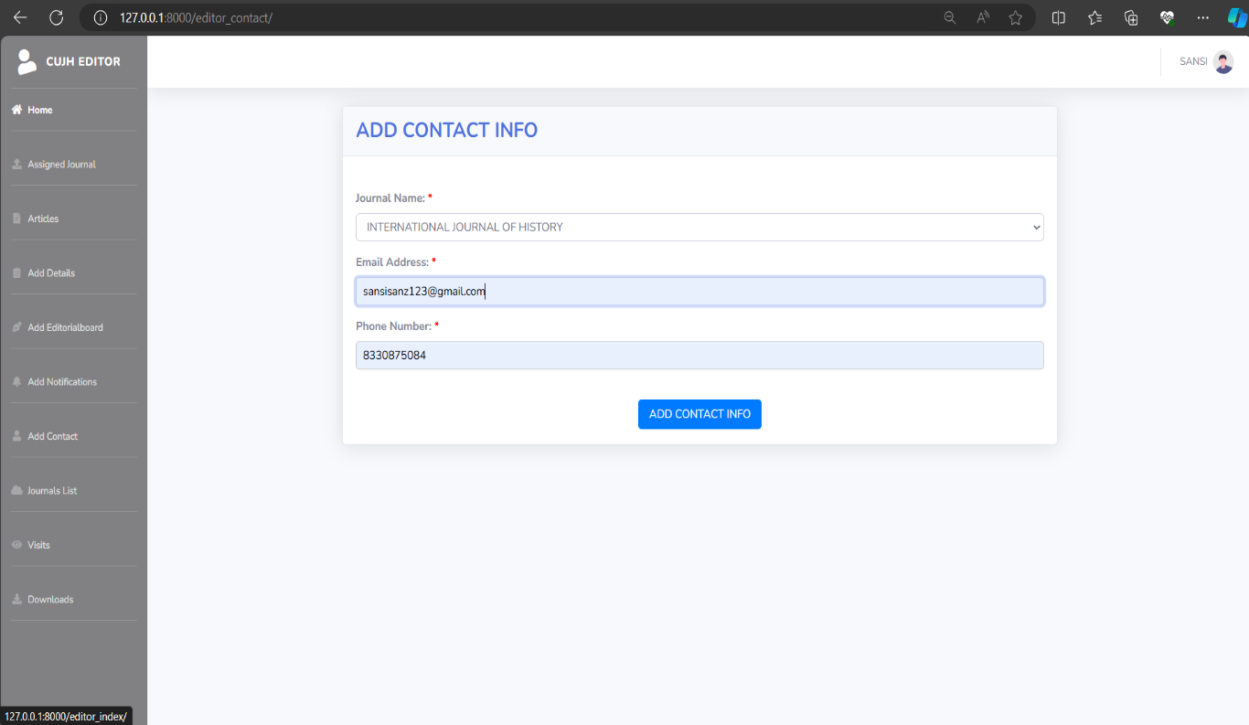

e

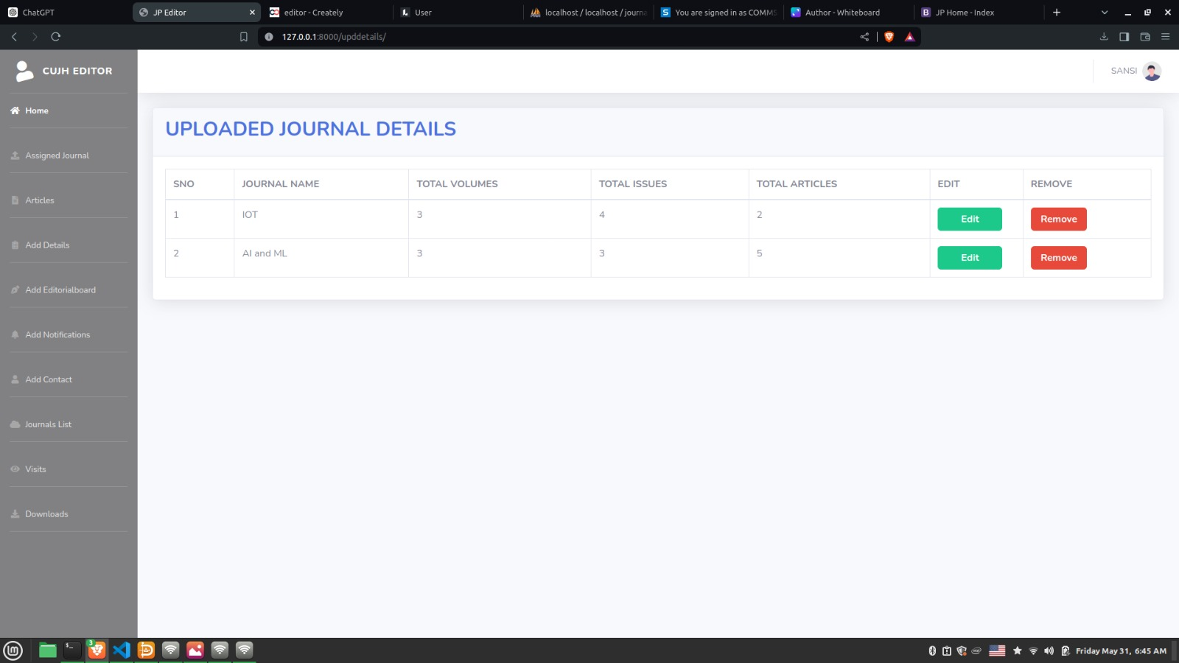



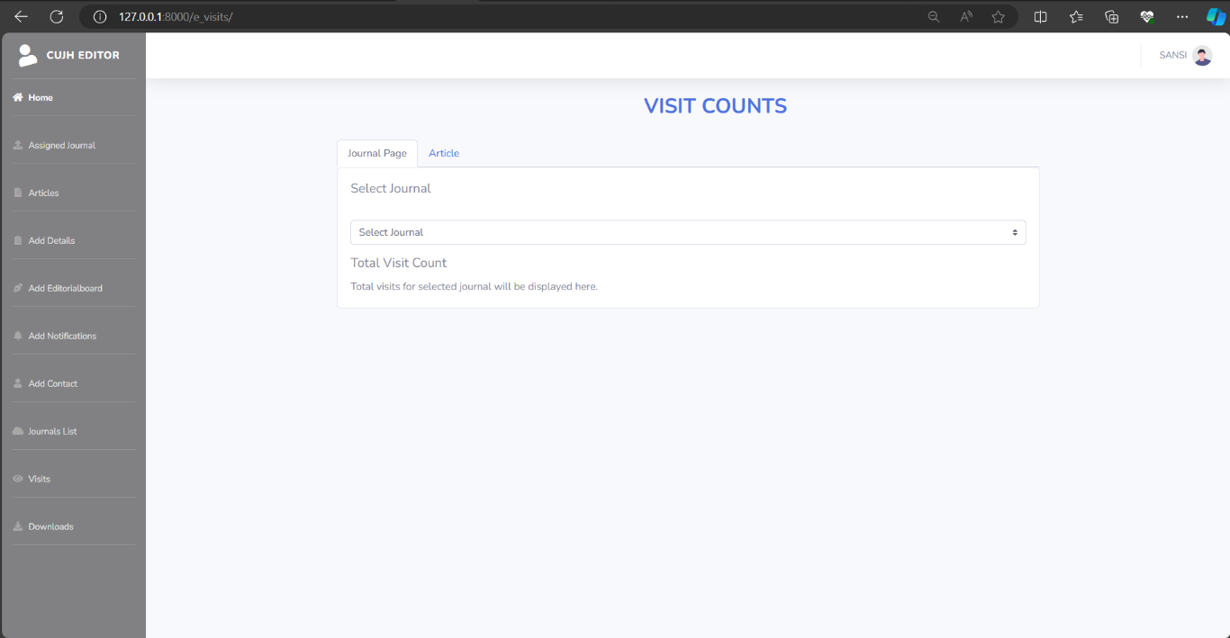

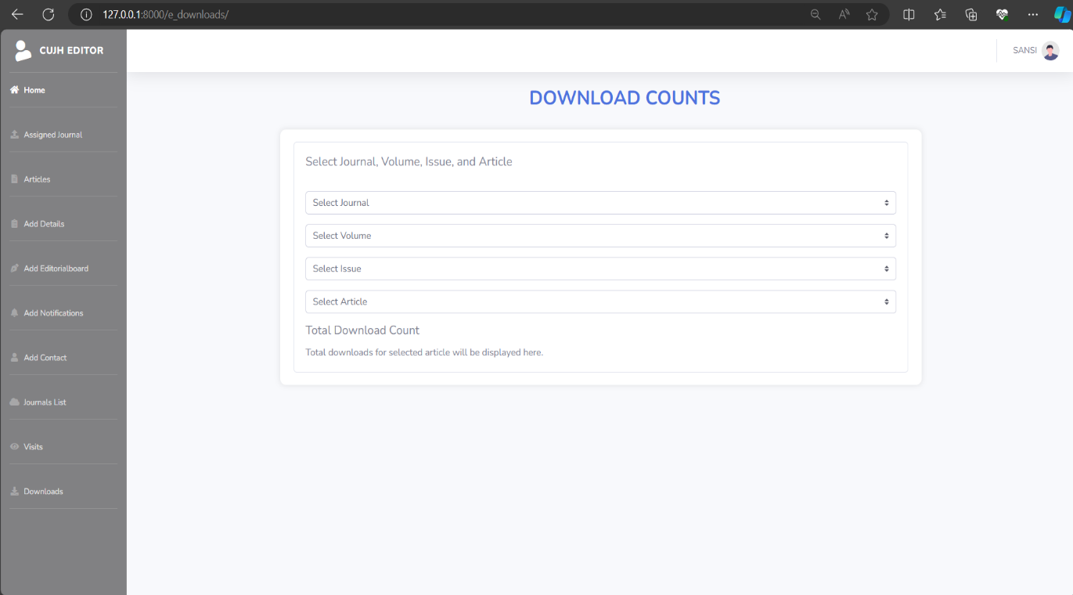



# BIBLIOGRAPHY



## BIBLIOGRAPHY

* <https://www.southindianhistorycongress.org/journal>
* <https://getbootstrap.com/docs/5.0/getting-started/introduction/>
* <https://3dflipbook.net/download-jq>
* [ChatGPT](https://chatgpt.com/?oai-dm=1)